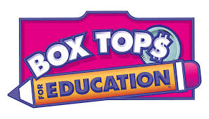

Thank you so much for sending in your Box Tops!
Our first submission date for the 2018/2019 school year is fast approaching; let’s make it a big one! Please send them in by Friday October 26th.

Check your cupboards and cabinets for Box Top labels and attach them to the worksheet or send them in a bag or envelope with your child. Please check for any expired Box Tops. We cannot submit any Box Tops with an expiration date prior to 11/01/2018.

COLLECT BOX TOPS FOR EDUCATION™ FOR YOUR SCHOOL!
™

Start clipping Box Tops today to help your kid’s school. Every Box Tops clip is worth 10¢ and quickly adds up to money that can help your school buy what it needs. Simply look for pink Box Tops on products, clip them and give them to your school. For more information on the Box Tops for Education program, including a list of participating products and how much your school has earned to date, visit www.btfe.com. Thanks for your help!
1
2
3
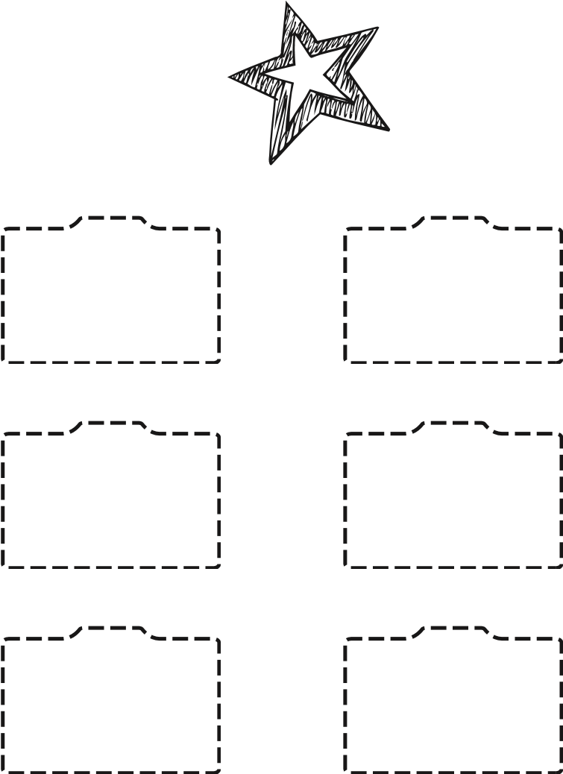
© General Mills.
Clip Box Tops.
Don’t forget to check the expiration date.
Tape or glue Box Tops on this sheet.
Send completed sheet to your school.

