2018-2019

OUR SCHOOL__Saint Helena School______________
OUR ID# ___24068__________________
A+ REWARDS PROGRAM RUNS 9/7/18 – 3/16/19
Supporting our School is easy as 1-2-3!
Get Started at giantfoodstores.com
if you need assistance call 1-888-814-4268 select option #1
1) Register for an online account or sign in to an existing one
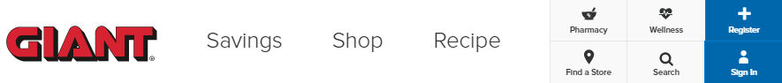

3) Select your preferred school(s) to reward
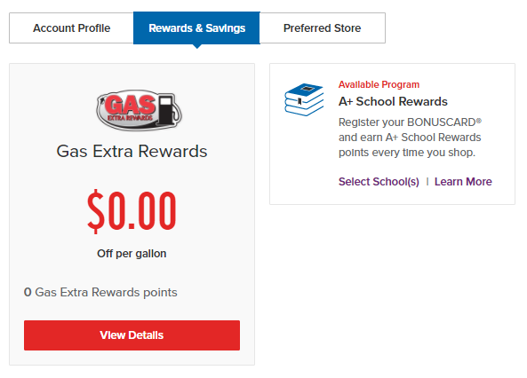
2) Access your account settings

   