Beginning November 3, 2020 - Saint Helena School will be transitioning from checking every student’s temperature at arrival to an online symptom assessment that will be completed by the parent, at home, prior to the student leaving the house.
- The symptom assessment will be completed through your FACTS online account and should be submitted each day no later than 7:45am. Below is a step by step guide for how to access and complete the symptom assessment.
- The assessment consists of four questions and requires that you check and record your child’s temperature.
- In the event that a parent forgets to complete the assessment the child will be called to the nurse’s office for the assessment to be completed and the nurse will contact the parent as a reminder.
- It is very important that the assessment is completed for each student every day. If the symptom assessment is consistently forgotten the principal, Mr. Jankowski, will contact the parent and may ask for the student to transition to virtual learning.
- In addition to the symptom assessment we will continue to spot check temperatures in the morning, with the goal to check 5% of the student body each morning.
Important changes to morning drop off: because we will not need to check temperatures for each student, we will reduce the number of drop off lanes to 5 lanes (all in the lower lot). The lane closest to the school will be reserved for families that have a Kindergartner/1st grader being dropped off. The remaining 4 lanes in the lower lot can be utilized by all families dropping off.
- Afternoon pick-up lanes will remain the same (due to the large volume of families picking up, we will continue to utilize the upper and lower lot and the procedures will remain the same).
Additional Note from the SHS Task Force: The Taskforce is continuing to monitor the COVID-19 events and trends in our area. Of note, there are elementary schools in the region that have closed for multiple weeks or quarantined multiple grades due to increased cases among students and teachers. Most hospitals in our region are also seeing an uptick in Covid-19 admissions.
While we are confident that Saint Helena School has the necessary measures in place to keep us as safe as possible, we want to remind our school families that caution and vigilance is required now more than ever. The contact tracing at the affected schools show that at least some of the cases are due to activities and gatherings outside of school (calling out that sports are a major cause of the mass quarantines). Please continue to be diligent in following Department of Health and CDC guidelines. Together, we can stay safe and keep our doors open.

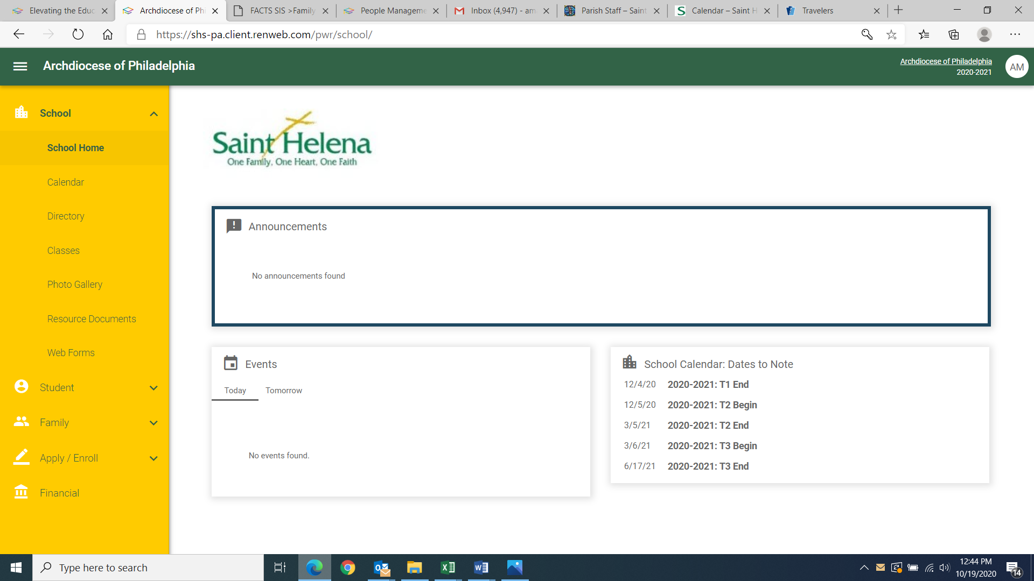
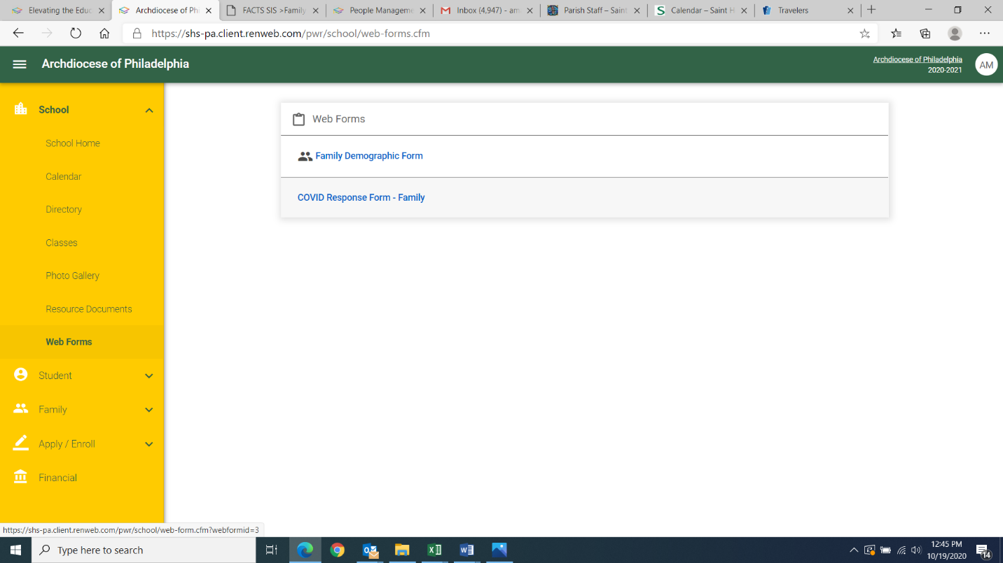
From the FACTS home page, click “web forms”
https://logins2.renweb.com/logins/ParentsWeb-Login.aspx
Choose “COVID Response Form-Family”
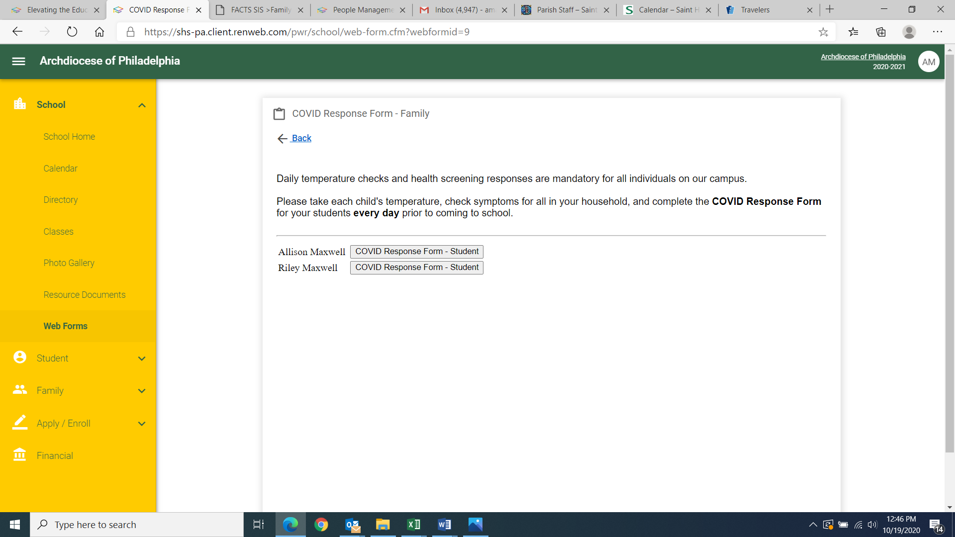
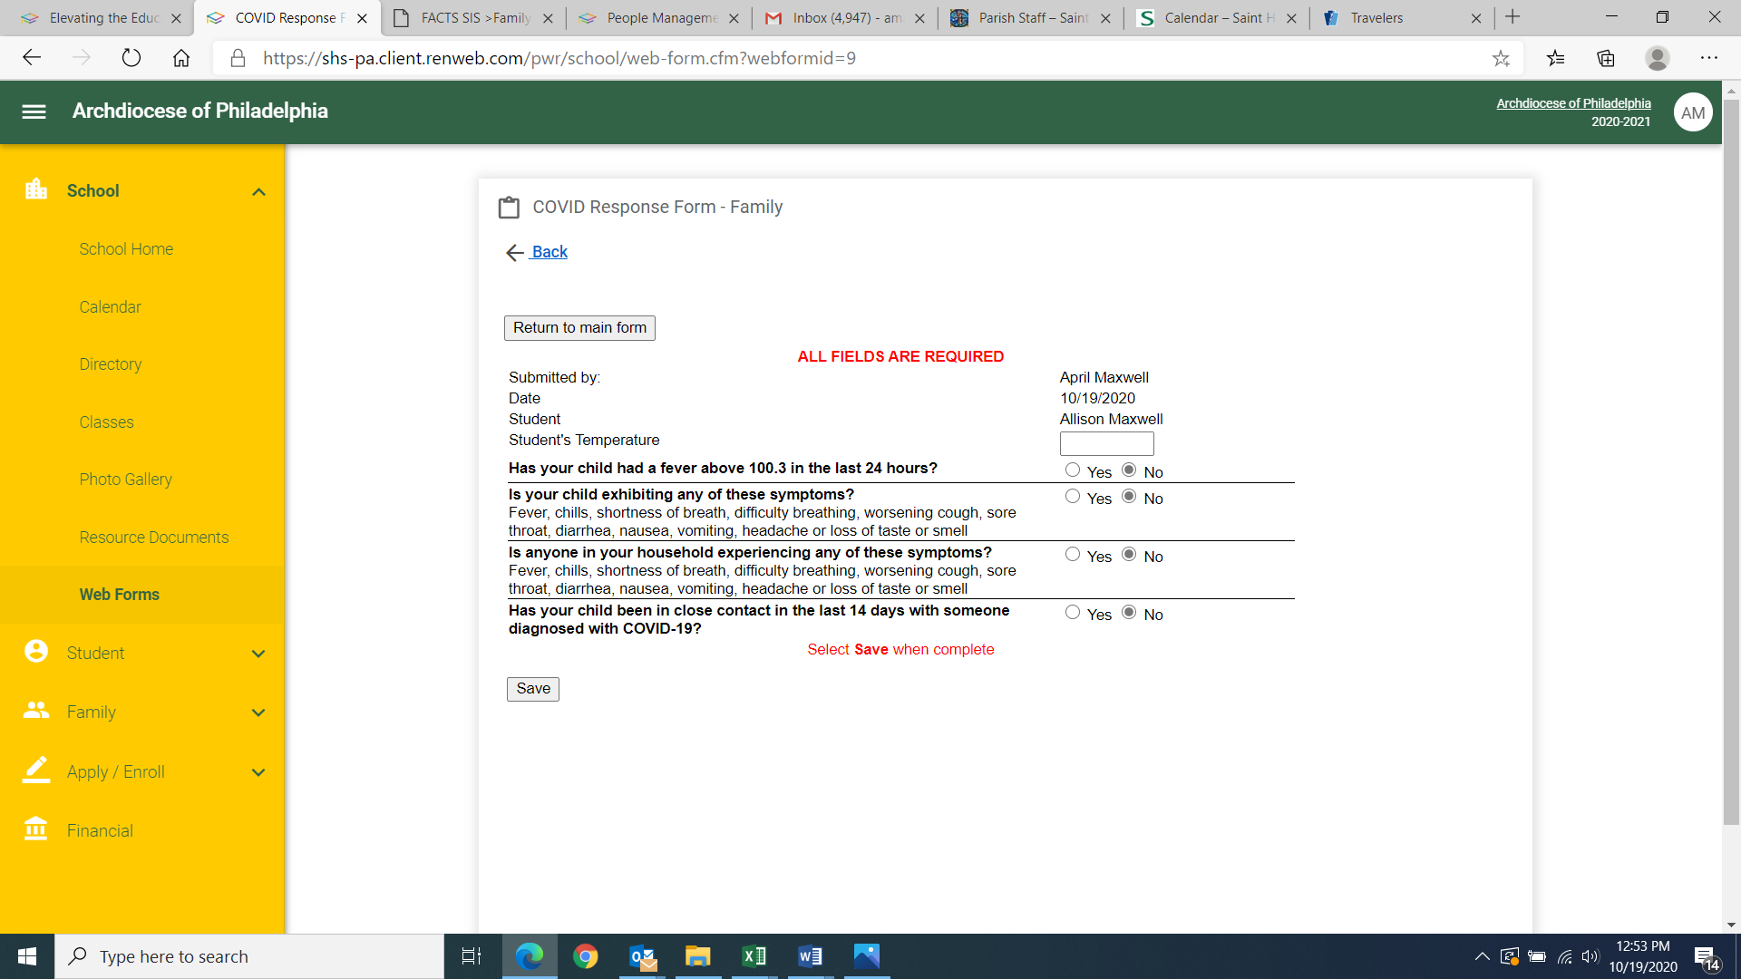
98.6
All fields need to be completed and the child’s temperature documented before the form can be submitted. If you answer “yes” in any of the fields your child should stay home from school.
There will be a separate form for each child

