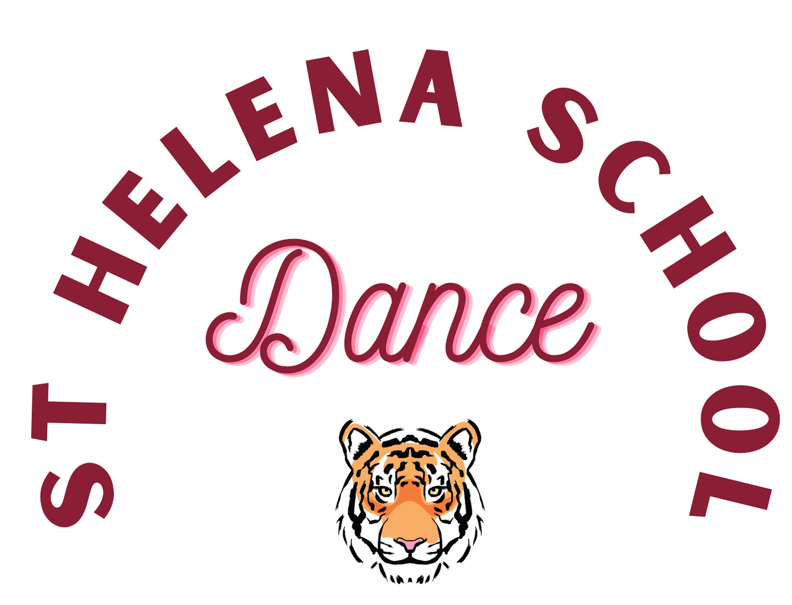

Mrs. Dana Leeds offers dance lessons for grades K through 8. She is beyond happy to celebrate her 10th year at SHS!

- Classes are held during the school day, at lunch recess, for a half hour.
Classes are once a week.
- Pink ballet shoes are required for class. Children dance in school uniform and ballet shoes during dance class. Children should wear shorts under their skirts/dresses.
- Classes occur in the SHS Dance Studio with a wood floor and mirrors.
- Dancers perform at various school functions, masses, the Parish Christmas Show in the Church, and the SHS Arts Festival in May.
- Classes consist of ballet, liturgical, lyrical/contemporary, jazz, hip-hop and modern dance. No experience needed! Kindergarteners also explore creative movement as they work on motor skills. The dance room is filled with fun dance props such as wands, scarves, bean bags, maracas, tambourines, and ribbon wands that encourage the dancers to use their imaginations, listen to rhythms, and dance freely!
- Dancers will improve strength, coordination, flexibility, rhythm and most importantly, confidence as they move. Having FUN is a must!
- Cost is $240 for each dancer.
A signed waiver must be returned with the sign-up sheet and payment to the school office labeled: Dance Leeds-Dance
First Semester starts the week of September 26, 2022 and ends January 13, 2023. A new sign-up form will be emailed for the second semester in January. Any questions, please email danaleeds923@gmail.com

Check to Dana Leeds
Forms due by Sept 21, 2022

Please fill out below information and return to school office with Waiver, Attn: Dana Leeds-Dance

Dancer Name:____________________________________Grade/Teacher:_______________________

$240

Dancer Name:____________________________________Grade/Teacher:_______________________

$240

Dancer Name:____________________________________Grade/Teacher:_______________________

$240

Payment Total:_______________

Parent email*______________________________________________

Parent cell___________________________________Parent Names____________________

*THIS EMAIL WILL BE THE EMAIL THAT ALL COMMUNICATION IS SENT REGARDING UPDATES AND DANCE LESSONS! I SEND WEEKLY EMAILS, SO PLEASE REACH OUT IF YOU ARE NOT RECEIVING THEM. THANKS!

