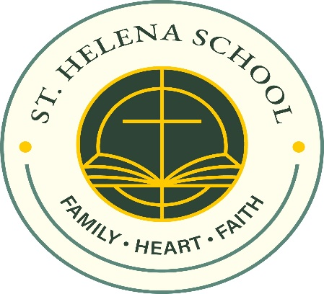

March 11, 2025

Dear Parents,

I want to take this time to share some important updates to the tuition set for next year and express my gratitude for another exciting year at Saint Helena School.

I am excited to share that the initiative to make our elementary teacher salaries more competitive has been extended. Now in its second year, this strategic plan is already showing remarkable results in the Archdiocese of Philadelphia. There has been significant improvement in teacher retention, a clear reflection of the positive impact of this effort. By offering competitive salaries, we are not only honoring the dedication of our current teachers, but also attracting exceptional new educators to join our community.

Of course, supporting our teachers also means ensuring the long-term sustainability of our schools. As part of this initiative, the Archdiocese has worked to increase scholarship funding to help offset the investment in salaries. This effort has been met with great success. Last year, we saw a notable increase in the scholarship funds available to our families, further underscoring our commitment to keeping Catholic education accessible to all who desire it for their children.

To support this, I encourage all parents to apply for scholarships through the Educational Improvement Tax Credit (EITC) program. The eligibility limits are generous, making this an excellent opportunity for many families to receive the financial assistance they need. By applying for EITC funds, you help ensure that Catholic education remains a viable and valuable option for your family and for others in our community.

I am deeply grateful for your unwavering support of Saint Helena School. Your commitment makes all of these advancements possible. Together, we are building a strong foundation for our students, one that is rooted in faith, academic excellence, and a deep sense of belonging.

**Now, is the time to enroll new siblings and returning students to Saint Helena School for next year. I will announce enrollment for new families** **in the next week. It is important for you to enroll as soon as possible. Some classes have many applicants and will fill up quickly. The re-enrollment deadline is April 4, 2025. Please see the attached for the new rates and details.**

As we look ahead, I am confident that the future of Saint Helena School remains bright, thanks to the dedicated teachers, engaged parents, and vibrant students who make up our exceptional community. We remain dedicated to ensuring your child receives the highest quality Catholic education. We are honored you have entrusted us with your child’s personal and academic formation. Together, we will continue to foster an environment where every student thrives and grows. Thank you for your continued commitment and support.

Sincerely,

**Miss Denise Britt**

Principal

**Saint Helena School**

1499 DeKalb Pike

Blue Bell, PA 19422

(610) 279-3345

[dbritt@sainthelenaschool.org](mailto:dbritt@sainthelenaschool.org)

[www.sainthelenaschool.org](http://www.sainthelenaschool.org)

Top of Form

Bottom of Form