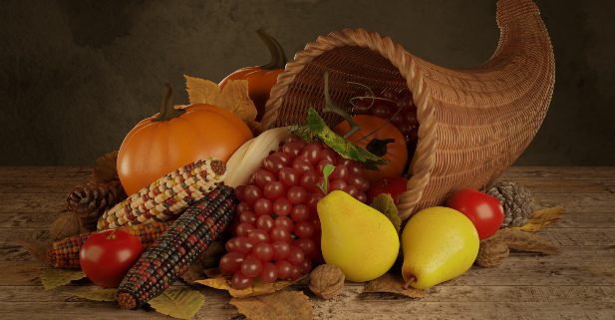

Please join us for a Mass of Thanksgiving and Simple Supper on Monday, November 24 at 6:00.
This year’s event will benefit Buddy Ball, an event started by Best Buddies. Buddy Ball is a year round special needs athletic league. They provide non-competitive sports and special events to children and adults who have physical, intellectual, and/or developmental disabilities to provide an opportunity to play, regardless of their abilities. Each sport is recreated in a way so no matter what the abilities of the athlete, they are able to participate and enjoy sports and recreational activities with the help of their “Buddies.” The program serves individuals in Montgomery County and the surrounding areas. Some of our older students are involved in their programs.
A simple meal of soup and bread will follow Mass in the school Gym. There is no cost to attend the supper, but it is our hope that the money you save on dinner for your family will be offered as a donation to Buddy Ball.
If you would like to donate to Buddy Ball, please bring a monetary donation to Mass or dinner on November 24. Cash and checks will be accepted. If you are not able to attend the Mass and Simple Supper and would like to donate to Buddy Ball, please send cash or a check made payable to Buddy Ball or Saint Helena School in an envelope clearly marked “Simple Supper” along with your family name.
So that we may adequately prepare for this special evening, please RSVP via the link by Wednesday, November 12. https://forms.gle/4hu9CWTrbz573Ej76

