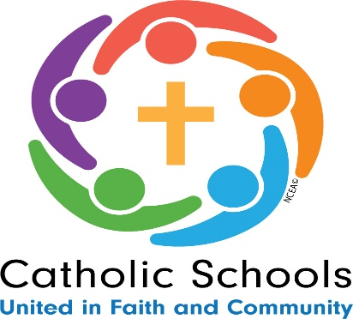

Catholic Schools Week Schedule- 2026
Faith, Excellence, Service

Date | Event
Sunday, Jan. 25, 2026  Celebrating Your Parish | Opening of Catholic Schools Week Mass 11:00 a.m.  Saint Helena School benefits all year long from the prayers and support our parishioners provide. Today we thank our parishioners for their support. We also celebrate our school and our teachers and thank God for our outstanding academic programs, religious education, and service opportunities rooted in the spirit of Mercy.  Saint Helena School Open House- 12:00-1:30. Come meet our students, teachers, parents, and principal to see what makes Saint Helena School so special.  Saint Helena School Book Fair begins today at 12:00 in the school library.
Monday, Jan. 26, 2026  Celebrating Your  Community | Thank you to Home and School for providing an assembly with Phil Martelli, former basketball coach of Saint Joseph’s University. 1:00- Grades 5-8  Students may wear their favorite team’s jersey or t-shirt over their regular school uniform.  Open Houses today in various grade levels.  Book Fair continues today.
Tuesday, Jan. 27, 2026  Celebrating Your  Students | Today we will celebrate the students by giving them a “Pajama” Dress Down Day, Breakfast for Lunch, and a fun afternoon. Students will play a fun game of BINGO with their prayer partners. The students will also enjoy a night without homework.  Thank you to our Home and School for providing an assembly with Science Spectacular! 10:00-11:00- Grades K-4  Open Houses this morning in various grade levels.  Book Fair continues today.
Wednesday, Jan. 28, 2026  Celebrating the Nation | Today we will celebrate our Nation by thanking the Whitpain Police Department. The thank you cards the students made for the police will be delivered to the police department today by some of our students, along with a treat.  Keystone Catholic Schools Week Event at Lansdale Catholic in the morning.  Open houses in various grade levels today.  Book Fair continues today.
Thursday, Jan. 29, 2026  Celebrating Vocations | Kindergarten Play- 10:30 – “How Does Your Garden Grow?”  Dress Down Day. Our school is collecting food to send to CHOP.  Today, the children will reflect on the gifts they have been given by God and consider the vocation they may be called to as they grow older.  The children will write letters to eight Sisters of Mercy who taught at Saint Helena School to thank them for the foundation of Mercy they laid in our school. The children will share the ways we continue to spread the charism of Mercy today.  Open Houses in various grade levels today..  Last day of the Book Fair.
Friday, Jan. 30, 2026 Celebrating Faculty | Today we will celebrate our “Senior Friends” by inviting them to a special performance in the Gym at 10:00.  The students have a 12:00 Dismissal today.  The teachers will be celebrated with a special lunch.  Parent Social –“Casino Night”- 7-11 PM at Normandy Farms, Blue Bell.

Catholic Schools Week Open House Schedule
Grades PreK 3 through Grade 4

Grade | Date/Time | Activity | Location
PreK3 | Tuesday, 1/27,  10:30 a.m. | Make your own rosary bracelet | PreK3 Classroom
PreK 4F | Thursday, 1/29,  1:30 p.m. | Memory Matching Game | Pre-K 4F Classroom
PreK 4K | Thursday, 1/29,  1:30 p.m. | Make sand art crosses | Pre-K 4S Classroom
Kindergarten | Thursday, 1/29,  10:30 a.m. | Please join us for our Kindergarten Play - “How Does Your Garden Grow?” | SHS Gym
1B | Thursday, 1/29, 9:00 a.m. | Snowman Craft | Cafeteria
1L | Thursday, 1/29, 9:00 a.m. | Snowman Craft | Cafeteria
2H | Tuesday, 1/27,  9:00 a.m. | S.T. R.E.A.M Spaghetti towers | Cafeteria
2J | Tuesday, 1/27,  9:00 a.m. | S.T. R.E.A.M Spaghetti towers | Cafeteria
3B | Wednesday, 1/28,  9:30 a.m. | Create a Hockey Rink | Cafeteria
3M | Wednesday, 1/28,  9:30 a.m. | Create a Hockey Rink | Cafeteria
4M | Monday, 1/26,  10:45 a.m. | Pennsylvania  Trivia | 4M Classroom
4J | Thursday, 1/26,  10:45 a.m. | Pennsylvania  Trivia | 4J Classroom

