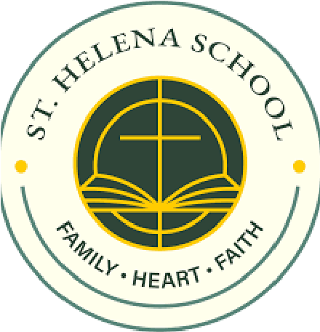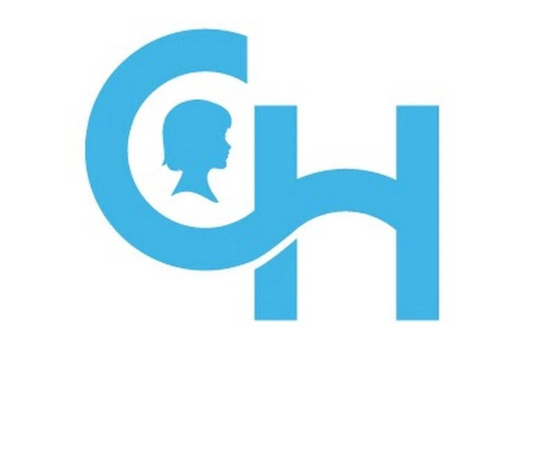
During Catholic Schools Week, St. Helena School will partner with 8th Grade Student Council Representative, Kieran Flatow and The Children’s Hospital of Philadelphia’s Allergy and Immunology department, to stock their new food pantry, ensuring every child has access to food that is safe for them to eat. Roughly 1 in 13 children live with food allergies, including many of our own classmates right here at St. Helena. For families visiting the Allergy & Immunology department at CHOP, finding "safe" food can be both difficult and expensive. This is our chance to help kids just like us eat safely!
On January 29th, please bring in a "safe" food donation from your class list below to participate in our Dress Down Day.

Pre-K/K: Pasta or Egg Noodles
Grade 1: Cereal Boxes
Grade 2: Sunflower Butter
Grade 3: Bisquick Mix
Grade 4: Oatmeal
Grade 5: Rice
Grade 6: Applesauce or Fruit Cups
Grade 7: Soup or Pasta Sauce
Grade 8: Soy Milk or Oat Milk (Non-Refrigerated Versions)

