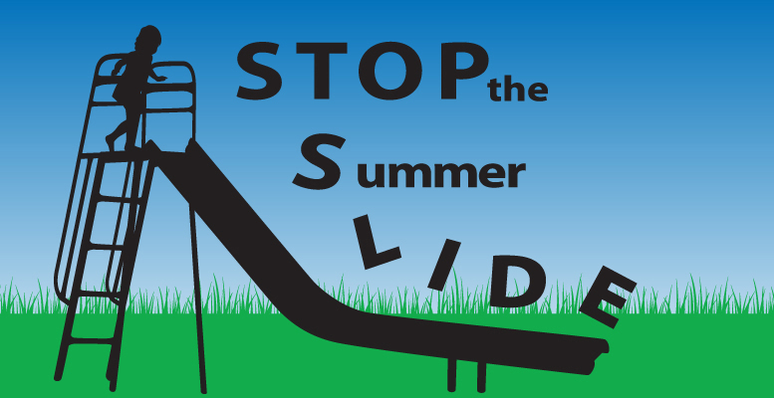
SAINT HELENA SCHOOL TEACHERS AVAILABLE FOR SUMMER TUTORING!

1.Mrs. Gina Facciolo- gfacciolo@sainthelenaschool.org
-available to tutor Grades Kindergarten through 4 in all subject areas.
2.Miss Michaela Hansen- mhansen@sainthelenaschool.org
-available to tutor Grades Kindergarten through 4 in math and reading.
3.Mrs. Danielle James- djames@sainthelenaschool.org
-available to tutor Grades Kindergarten through 6 in all subject areas.
4.Ms. Ann Kirk- akirk@sainthelenaschool.org
-available to tutor Grades 1 through 8 in all subject areas.
5.Miss Lona Krebs- lkrebs@sainthelenaschool.org
-available to tutor Grades Kindergarten through 8 in ELA.
-Miss Krebs is available to tutor now, too.
6.Mrs. Jennifer Laub-jlaub@sainthelenaschool.org
- available to tutor for the HSPT & Math for Grades 4 through high school.
7. Mr. Grant May- gmay@sainthelenaschool.org
- available to tutor Grades 1 through 8 in math, science, and social studies.
8. Mrs. Christine McNally- cmcnally@sainthelenaschool.org
- available to tutor Grades Kindergarten through 4 in math and reading.
9. Miss Nicole Tasey- ntasey@sainthelenaschool.org
- available to tutor Grades Kindergarten through 6 in all subject areas.

