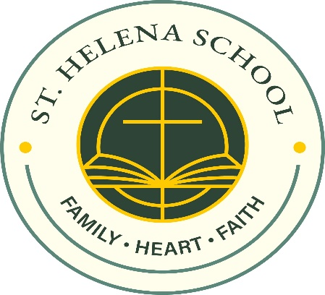
Dear Saint Helena School Families,
Over the years, our school community has experienced the loss of children who remain very dear to our hearts. Their lives continue to inspire us, and their legacies live on through foundations created in their honor.
As a school community, we have reflected on how we can come together in a way that is inclusive, meaningful, and united in remembrance. This year, we will continue Legacy of Love Day, a school-wide dress down day dedicated to honoring these cherished children and supporting the foundations established in their memory: the Erin Delia Moore Fund for Children with Cancer, the John Shapiro’ Superheroes Foundation, Landon Vargas Miles of Smiles Foundation, and the Kellan Ford Foundation.
All funds raised will be split evenly among these four foundations, ensuring that each legacy is supported. This day provides an opportunity for our students to witness the power of compassion, unity, and generosity as we come together as one school family.
We remain deeply supportive of the individual events and initiatives connected to each foundation. Legacy of Love Day is one meaningful way we can collectively remember and honor these children together.
This year’s Legacy of Love Day will be held on Wednesday, April 8.
Thank you for your continued generosity and for partnering with us in teaching our children the importance of empathy, remembrance, and community.
Sincerely,
Denise Britt

