Everything Disney!

Calling all incoming Pre-K to 3rd graders! Come take a trip to Disney with Mrs. Facciolo!
We will explore what it would be like to visit each of the four parks with virtual field trips, games, crafts, trivia, sing and dance alongs, and Disney treats!

Day 3
Day 1

Park: Magic Kingdom Park: Hollywood Studios
Theme: Princess/Pirates Theme: Fav Disney Film
Day 2

Park: Animal Kingdom
Theme: Animals
Day 4
Day 5

Park: Epcot Global Disney Day!
Theme: World of Tomorrow Theme: All Disney Parks


If interested, please fill out this form on the next page by Friday, May 8th 2026!
Limited Availability
Price per student $295
Non-Refundable

Checks made payable to Saint Helena School
Snacks will be provided each day.
Email: gfacciolo@sainthelenaschool.org
St. Helena School
Dates: June 15-19, 2026

Monday- Friday 9:00am to 12:30pm

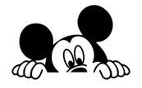
Disney Summer Camp 2026
Please fill out the attached form by May 8th, 2026 and send to school attention: Mrs. Gina Facciolo Disney Camp!

Please make checks payable to St. Helena School. (payment is non-refundable)

Child’s Name: ______________________________________
Grade in September 2026:____________________________
Allergies:_________________________________________________________________________________________
Email:____________________________________________
Phone Number:_____________________________________
Secondary Contact Name:____________________________
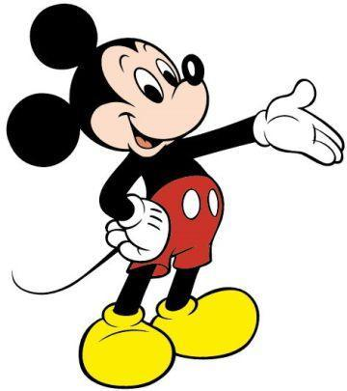
Phone Number:_____________________________________
Total Enclosed:_____________________

